Weekend of 1-3 October - Trip Report
The long weekend began with a lot of promise and the largest group of boats
(12) in numerous trips. As usual the weather caused changes right away with
the planned meeting at Peel Island adjusted after the first few boats on the water
reported winds on the open water were stronger than forecast. Wine Knot, Jesse
and new members Tony and Jane still met up at Peel and had a fish with winds
dying down and conditions improving. Updates were made to the webpage with
changes to the meeting for happy hour at Karragarra and phone calls were made
to those that answered, but still there was some confusion as to who to contact.
For future reference it should only be the trip coordinator. After some discussions
it was decided happy hour and overnighting at Canaipa was the safest for all.
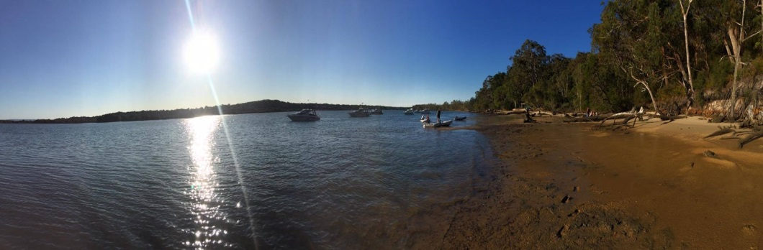
Happy hour was a great success with 10 boats arriving and anchoring overnight.
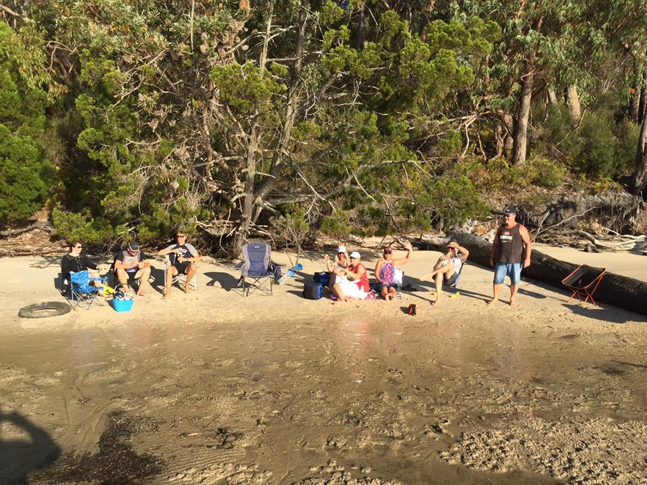
The Sunday awoke to flat water and remembering discussions at Happy Hour the night
before of how perfect the weather condition were going to be for some whale watching.
Four boats, Cisco, Lusea, Wine Knot and Jesse headed south for the Gold coast seaway
and went out about a Kilometre straight out and whales appeared! Numerous tail
slaps, breaches, and rolls and even a few full breaches made for a great show.
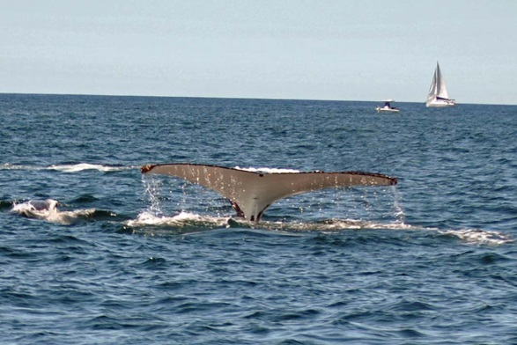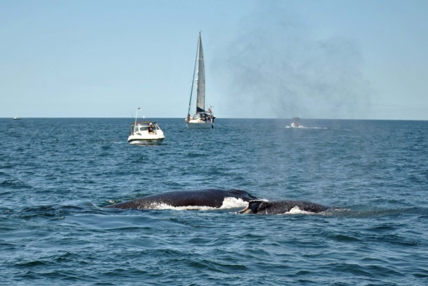
After the morning whale watching is was back to schedule of Happy hour at Tipplers at
the normal time, leading into the evening booking at Tipplers Café for Grand Final football
on the big screen! A great success again as it was last year but again with the wrong team
winning! Most boats headed out early on Monday as weather conditions were forecast
to worsen. Great weekend for All!

Report by Rob Wood
Trip Coordinator

